Layout Weights

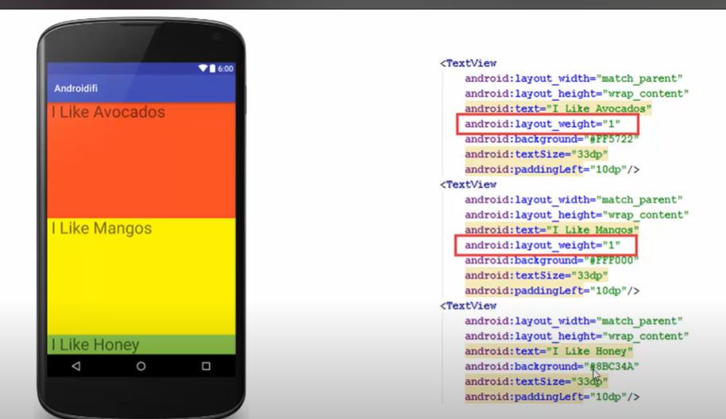

Default Value is 0 of layout weights